**T**ranslation from English to Arabic language using artificial intelligence techniques

# Introduction

There are limited freely available services that provide an accurate translation from English to Arabic. Most of these services hardly use the grammatical analysis to produce accurate translation. For example, Google translator [Google2015] translates the phrase “I would like to have an apple” in Arabic to

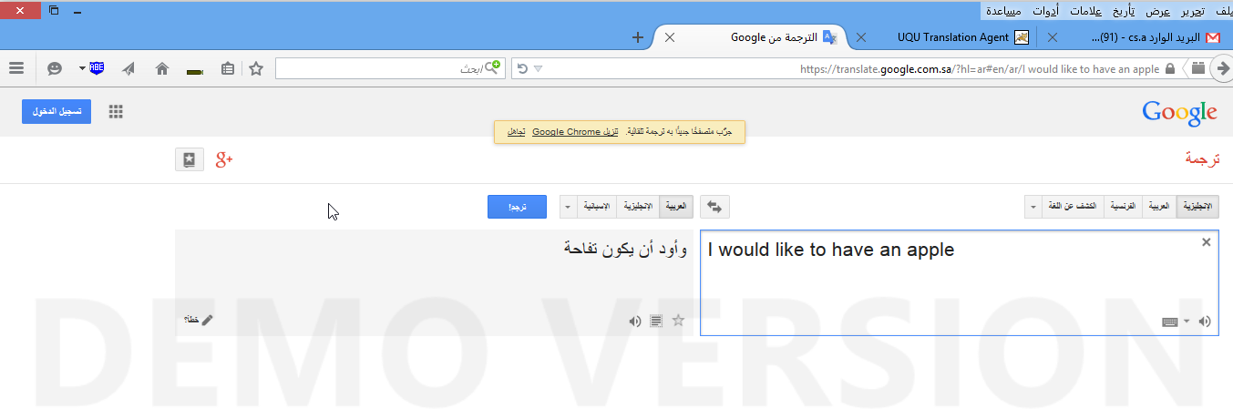

# Goals :

The goal of project is to provide accuracy transition from English to Arabic using multi agents systems and neural networks a real complex agents work to together every engine have a job to do

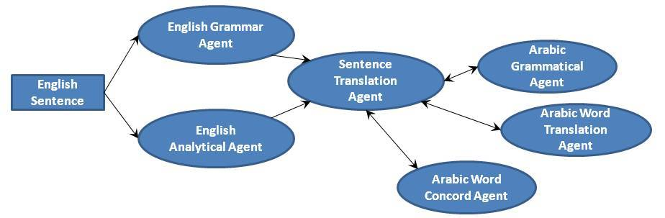

The goals of project is succeed :

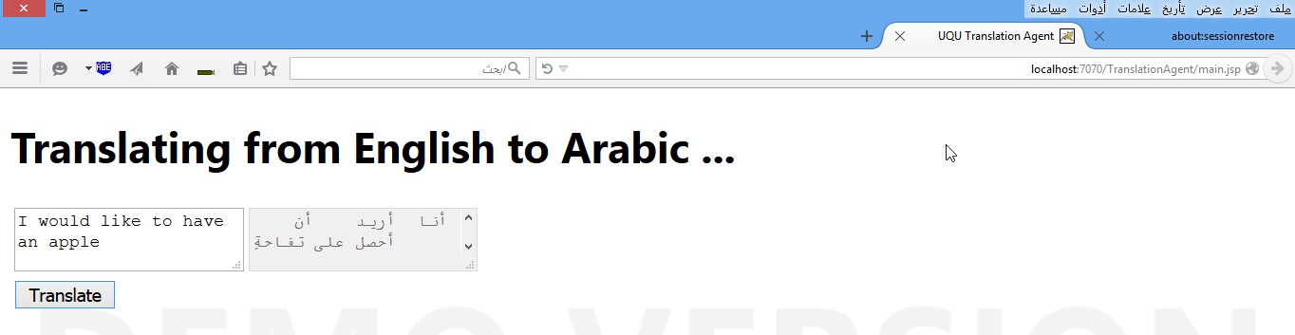

**95 grade in gradation project (A+)**

# Conclusion and Future Work

The translation quality can be improved by implementing a system for document translation and not restrict it to single sentence. The document should be processed by intelligent agents that will determine the domain of the document. The translation agent should use the domain knowledge to choose words and grammar that is more suited to text from this domain. This is an important future extension that should be added to the project

Add more words in the translation tables add more grammatical conversion between the English and Arabic language